**Virtual and Augmented Reality Assignment 1**

**The 3D Maze**

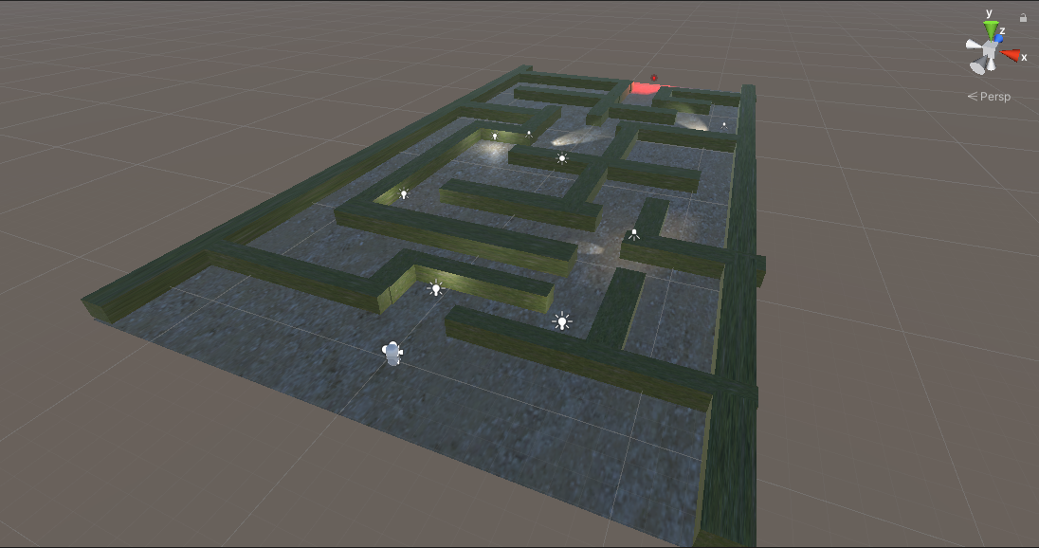

Figure - Overview of the maze

The maze was created using primitive 3D objects, specifically 3D cubes. Each instance of the walls are instances of the “Maze Wall” prefab. This uses the “GrassHillAlbedo” material which came from The Standard Assets package. The floor of the maze was created using a Plane object that uses the “SandAlbedo” material from the same package.

Figure 3 - The Maze Wall prefab (showing the Material component)

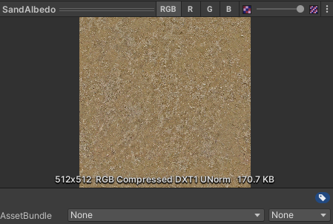

Figure 2 - The SandAlbedo material

**The Player**

The player object is a 3D capsule object attached to an instance of the FPSController object (from Standard Assets package) in order to move in first-person by using the keyboard and mouse.

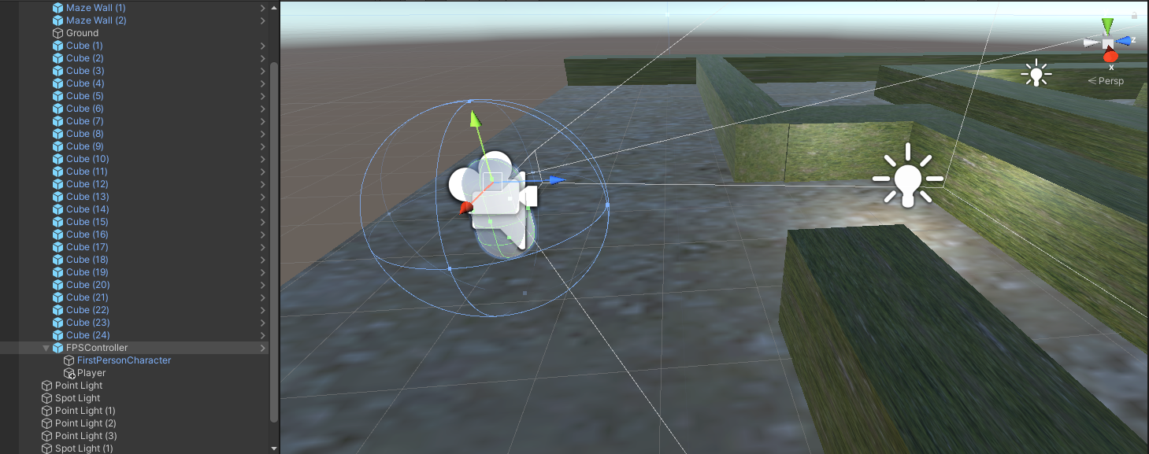

Figure - The player object

**Lighting**

The scene is lit using point lights and spotlights. The default directional light that comes with the vanilla scene has its light intensity set to 0 in order to make the maze dark. This helps the point lights and spotlights to be more visible to the player.

These lights are placed strategically in order to guide the player to navigate the maze. At the end of the maze is a point light with the color red to indicate the end of the maze.

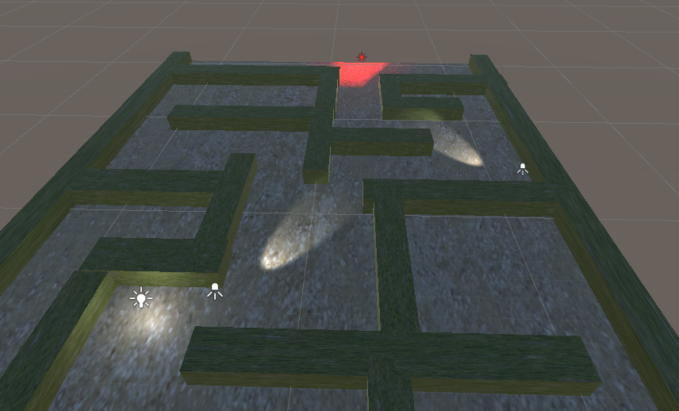

Figure - Placement of point lights and spotlights to show the player where to go